Introduction

We plan on implementing functionality to enable students to access e-learning with their android gadgets. Kenya is considered one of the most technology-advanced countries in Africa, and having approximately 20.6 million Kenyans that own an android mobile phone the idea is well fit. An online class has many activities that have to be accommodated such as: Online meetings links distribution, conducting live/online video classes, distribution of tutorials, student forums, Announcements, conducting exams/CATS/Assignments… (among others).

Currently, some of these services are non-existent in android or they happen to be in different isolated platforms, requiring students to acquire multiple apps to perform their academic duties. We look onto bringing these different components/services under one shed (our platform) and implementing the non-existent, which will make it easier for the student to keep track of their academic matters. The aim of the project is to develop a user-friendly platform which organises course content in an efficient way for student consumption as well as facilitate easier administration of classes by lectures, administrator and providing a reliable communication channel for all parties involved.

System Analysis

4.1. Feasibility Study

4.1.1. Technical Feasibility Study

4.1.2. Economic Feasibility Study

4.1.3. Operational Feasibility Study

4.1.4. Social Feasibility Study

4.2. Requirements Specification

4.2.1. Functional Requirements

4.2.2. Non-Functional/Quality Requirements.

4.2.3. Hardware Requirements

4.2.4 Software Requirements

4.3. System Constraints

4.4. Use Case Diagram

System Design

5.1. Conceptual Design

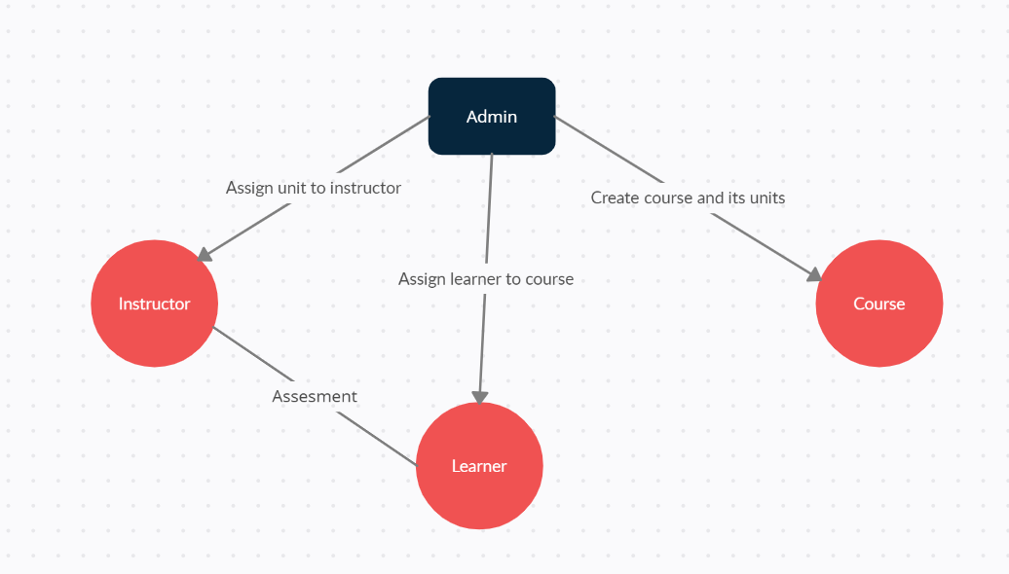

5.2. Architectural Design and System Components

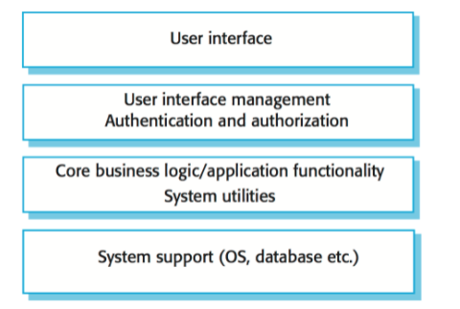

User Interface

We will use Figma to design the UI of the system. There will be some 3D components for the UI as well, which we will design with Spline and Three.js.

Authentication and Authorization.

We will use Firebase Authentication.

Chatbot

We will use a chatbot for the frequently asked questions. This is where we use some bit of machine learning to help gather information about the learner or instructor.

Database

There are five tables for our database, Admin, Courses, Units, Learner and Instructor. The instructor, teaches a certain unit which belongs to a certain course. The learner is taking one or more courses

5.3. Database Design

There are five tables for our database, Admin, Courses, Units, Learner and Instructor.

The instructor, teaches a certain unit which belongs to a certain course.

The learner is taking one or more courses.

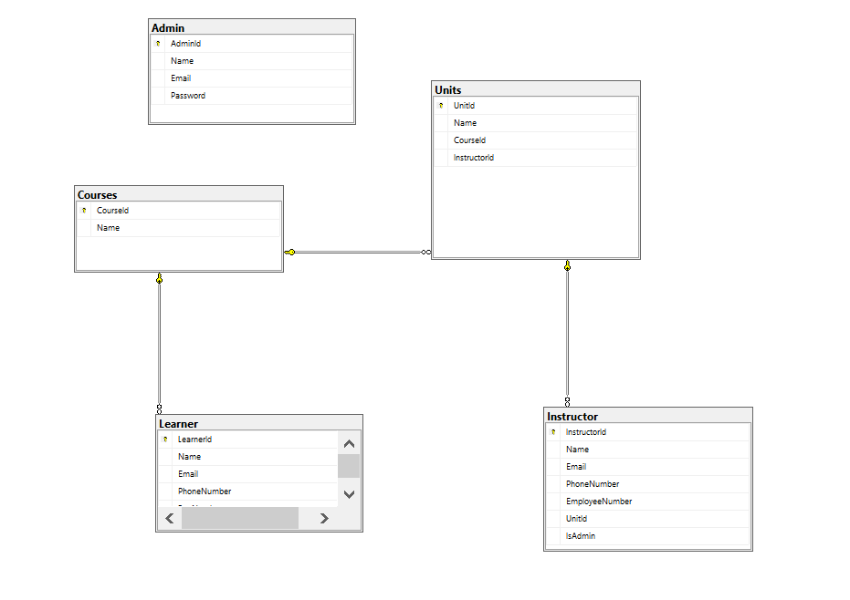

5.4. User Interface Design.

For the user interface, we’ll be using UI/UX design techniques to come up with a good user interface that is delightful and at the same time built to deliver learning content efficiently to learners. We will be using 3D components to make the user interface delightful and draw the attention of the learner. We will use Three.js and Spline for the 3D components. The basic design will be done with Figma, then the 3D components with Spline.

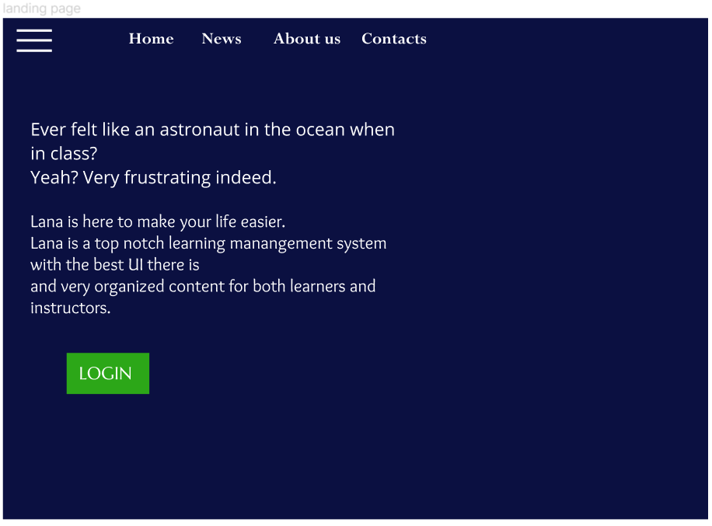

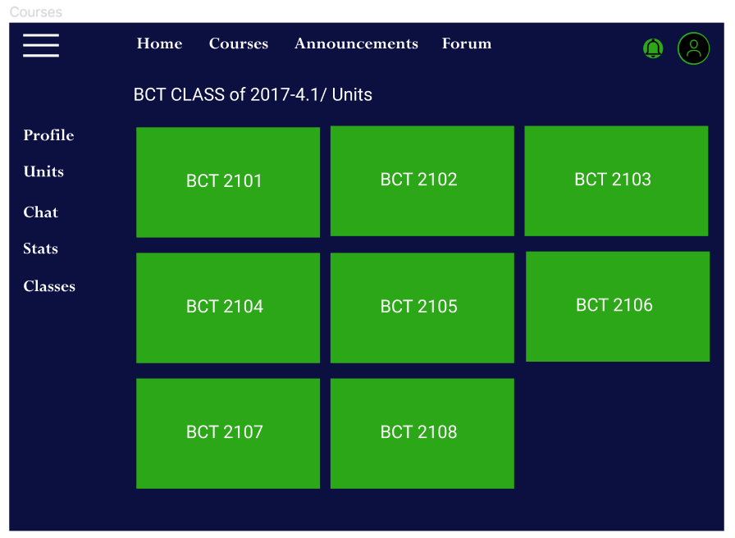

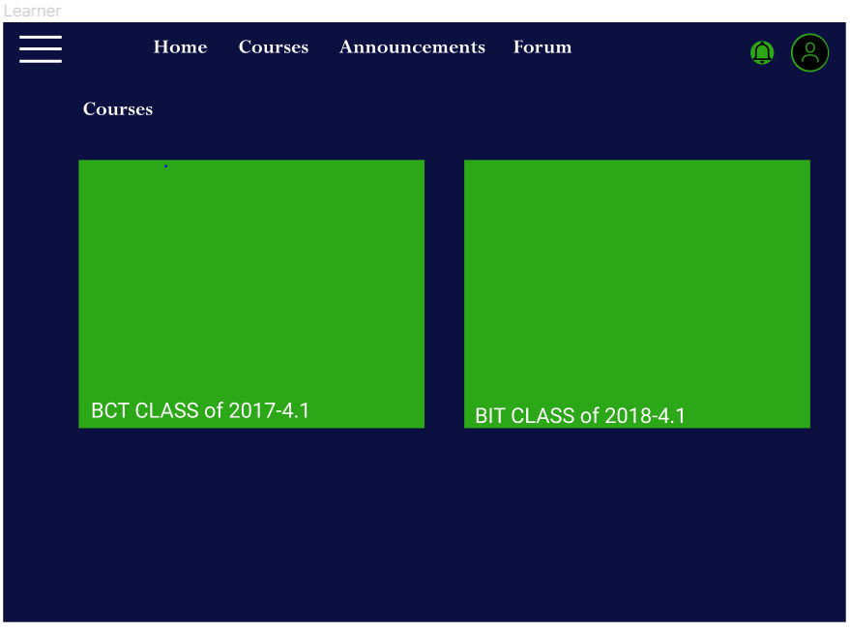

5.5. UML diagrams

Use Case Diagram.

